Name: Eli R DeWitt  
Date: 2/22/2022

**08.06 Picture Lab Worksheet**

**Directions**: Make note of your responses to the following questions as you work through the activities and exercise in the lesson.

# **Activity 1 Questions**

1. How many bits does it take to represent the values from 0 to 255? **8**
2. How many bytes does it take to represent a color in the RGB color model? **24**
3. How many pixels are in a picture that is 640 pixels wide and 480 pixels high? **307200**

# **Activity 2 Questions**

1. How can you make pink? **java.awt.Color[r=255,g=0,b=255]**
2. How can you make yellow? **java.awt.Color[r=255,g=255,b=0]**
3. How can you make purple? **java.awt.Color[r=100,g=0,b=255]**
4. How can you make white? **java.awt.Color[r=255,g=255,b=255]**
5. How can you make dark gray? **java.awt.Color[r=80,g=80,b=80]**

# **Activity 3 Questions**

1. What is the row index for the top left corner of the picture? **0**
2. What is the column index for the top left corner of the picture? **0**
3. The width of this picture is 640. What is the right-most column index? **639**
4. The height of this picture is 480. What is the bottom-most row index? **479**
5. Does the row index increase from left to right or top to bottom? **Top to Bottom**
6. Does the column index increase from left to right or top to bottom? **Left to Right**
7. Set the zoom to 500%. Describe what you see. **It’s heavily zoomed in, you can see the pixels have significant size**

# **Activity 3 Exercise Results**

1. After modifying the main method in the PictureExplorer class to create and explore a different picture from the images folder, paste the code below.
2. After scaling your image, paste the new main method code below.

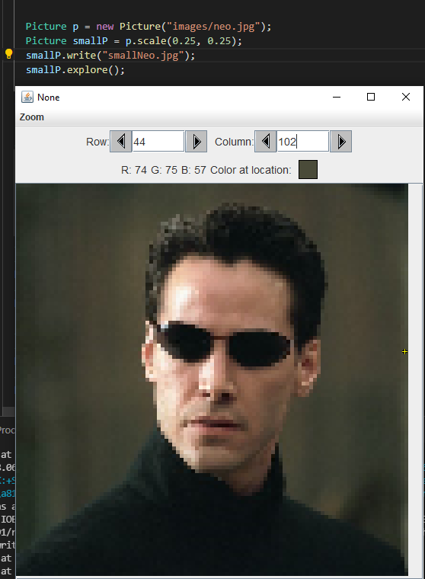

# **Activity 4 Exercise Results**

1. What was the output result after running the getCount method?  
   Paste your getCount method below.

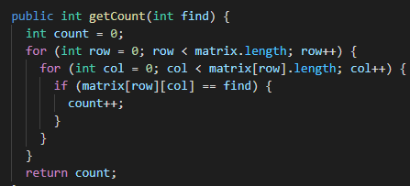

1. What is the output result after running the getLargest method?  
   Paste your getLargest method below.

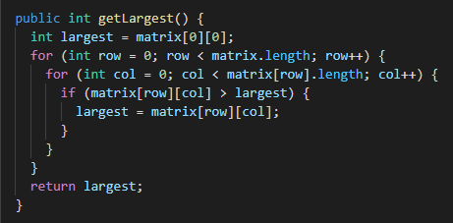

1. What is the output result after running the getColTotal method?  
   Paste your getColTotal method below.

